# MACHINE LEARNING LAB PROJECT

# SALES PREDICTION

***B.Tech III yr* (Computer Science & Engg.)**

Submitted To:

Submitted by:

Jyoti Vyas Mam

Assistant professor Nitin Gehlot

III year V semester

# 

# Acknowledgment

I would like to acknowledge the contributions of the following people without whose help and guidance this project would not have been completed

I respectfully thank Jyoti Vyas Mam , for providing me an opportunity to do this project work and giving me all support and guidance, which made me complete the project up to very extent.

I am also thankful to Mamta Garg Mam, HoD of Computer Science and Engineering Department, Jodhpur Institute of Engineering and Technology, for his/her constant encouragement, valuable suggestions and moral support and blessings.

Although it is not possible to name individually, I shall ever remain indebted to the faculty members of Jodhpur Institute of Engineering and Technology, for their persistent support and cooperation extended during his work.

This acknowledgement will remain incomplete if I fail to express our deep sense of obligation to my parents and God for their consistent blessings and

encouragement.

**TABLE OF CONTENTS**

1. **INTRODUCTION 1**
2. **TECHNOLOGY USED IN PROJECT 2**
3. **DETAILS OF PROJECT**
   1. **Functions/Modules Details**
   2. **Flow Chart**
   3. **Project Code**
   4. **Project Screenshots**

**4.APPLICATIONS**

1. **CONCLUSION AND FUTURE WORK**
2. **REFERENCES**

# 

# Introduction

Sales prediction is a critical aspect of business strategy, enabling organizations to anticipate customer demand, optimize inventory levels, and enhance overall operational efficiency. In the era of big data, leveraging machine learning techniques for accurate sales forecasting has become increasingly important. This project focuses on developing a predictive model that utilizes historical sales data to forecast future sales trends.

By applying various machine learning algorithms, such as linear regression, decision trees, and neural networks, we aim to identify patterns and relationships within the data that can inform sales predictions. Our approach involves data preprocessing, feature selection, and model evaluation to ensure the robustness and accuracy of the predictions.

The findings from this project not only highlight the effectiveness of machine learning in sales forecasting but also provide valuable insights for businesses seeking to improve their decision-making processes. Ultimately, this project demonstrates how data-driven strategies can lead to enhanced competitiveness and profitability in the retail sector.

# Technology used in Project

• **Programming Language:**

* **Python:** The primary language for machine learning and data analysis.

• **Libraries and Frameworks:**

* **Pandas:** For data manipulation and analysis.
* **NumPy:** For numerical operations and array handling.
* **Scikit-learn:** For implementing machine learning algorithms and evaluation metrics.
* **TensorFlow or PyTorch:** For deep learning models, if needed.

**Data Visualization Tools:**

* **Matplotlib:** For creating static visualizations.
* **Seaborn:** For enhanced statistical visualizations.
* **Plotly:** For interactive visualizations (optional).

• **Integrated Development Environment (IDE):**

* **Jupyter Notebook:** For interactive coding and data exploration.
* **PyCharm or VS Code:** For a more comprehensive coding environment.

# Details of Project

In this section give the details of the work done during the training period. Following below details are required.

* 1. Flow Chart
  2. 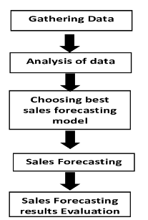
  3. Functions/Modules Details

### Data Collection Module

* **Description:** This module focuses on gathering historical sales data and any other relevant datasets (e.g., marketing campaigns, customer demographics, seasonal data).

### Data Preprocessing Module

* **Description:** This module prepares the collected data for analysis by cleaning and transforming it.
* **Key Tasks:**
  + Handle missing values (imputation or removal).
  + Remove duplicates and outliers.

### Model Selection Module

* **Description:** This module is responsible for selecting appropriate machine learning algorithms for the prediction task.
* **Key Tasks:**
  + Research and select algorithms (e.g., linear regression, decision trees, random forests, neural networks).

### Model Training Module

* **Description:** This module involves training the selected models on the training dataset.
* **Key Tasks:**
  + Split the dataset into training and testing subsets.
  + Train the models using the training data.
  1. Project Code

import numpy as np

import pandas as pd

from sklearn.model_selection import train_test_split

from sklearn.linear_model import LinearRegression

from sklearn.metrics import mean_squared_error, r2_score

from sklearn.preprocessing import StandardScaler

from sklearn.preprocessing import LabelEncoder

np.random.seed(42) # For reproducibility

data_size = 100

item_category = np.random.choice(['smartphone', 'laptop', 'TV', 'tablet', 'camera'], data_size)

store_size = np.random.choice(['small', 'medium', 'large'], data_size)

ad_spend = np.random.randint(1000, 50000, data_size) # Ad spend in dollars

discount = np.random.uniform(0, 50, data_size) # Discount percentage

holiday_season = np.random.choice([0, 1], data_size) # 0 for no, 1 for yes (holiday season)

base_sales = {

'smartphone': 800, 'laptop': 1000, 'TV': 1500, 'tablet': 600, 'camera': 500

}

sales = [(base_sales[category] + (ad * 0.05) + (50 - disc) * 10 + (500 if holiday else 0) + np.random.randint(-200, 200))

for category, ad, disc, holiday in zip(item_category, ad_spend, discount, holiday_season)]

df = pd.DataFrame({

'Item_Category': item_category,

'Store_Size': store_size,

'Ad_Spend': ad_spend,

'Discount': discount,

'Holiday_Season': holiday_season,

'Sales': sales

})

label_encoder = LabelEncoder()

df['Item_Category'] = label_encoder.fit_transform(df['Item_Category'])

df['Store_Size'] = label_encoder.fit_transform(df['Store_Size'])

X = df[['Item_Category', 'Store_Size', 'Ad_Spend', 'Discount', 'Holiday_Season']]

y = df['Sales']

X_train, X_test, y_train, y_test = train_test_split(X, y, test_size=0.2, random_state=42)

# Scale features (optional but helps with models like Linear Regression)

scaler = StandardScaler()

X_train_scaled = scaler.fit_transform(X_train)

X_test_scaled = scaler.transform(X_test)

model = LinearRegression()

model.fit(X_train_scaled, y_train)

y_pred = model.predict(X_test_scaled)

mse = mean_squared_error(y_test, y_pred)

r2 = r2_score(y_test, y_pred)

print('Linear Regression:')

print(f'Mean Squared Error: {mse:.2f}')

print(f'R-squared: {r2:.2f}')

csv_file_path = '/content/shop_sales_electronics.csv'

df.to_csv(csv_file_path, index=False)

* 1. Project Screenshots

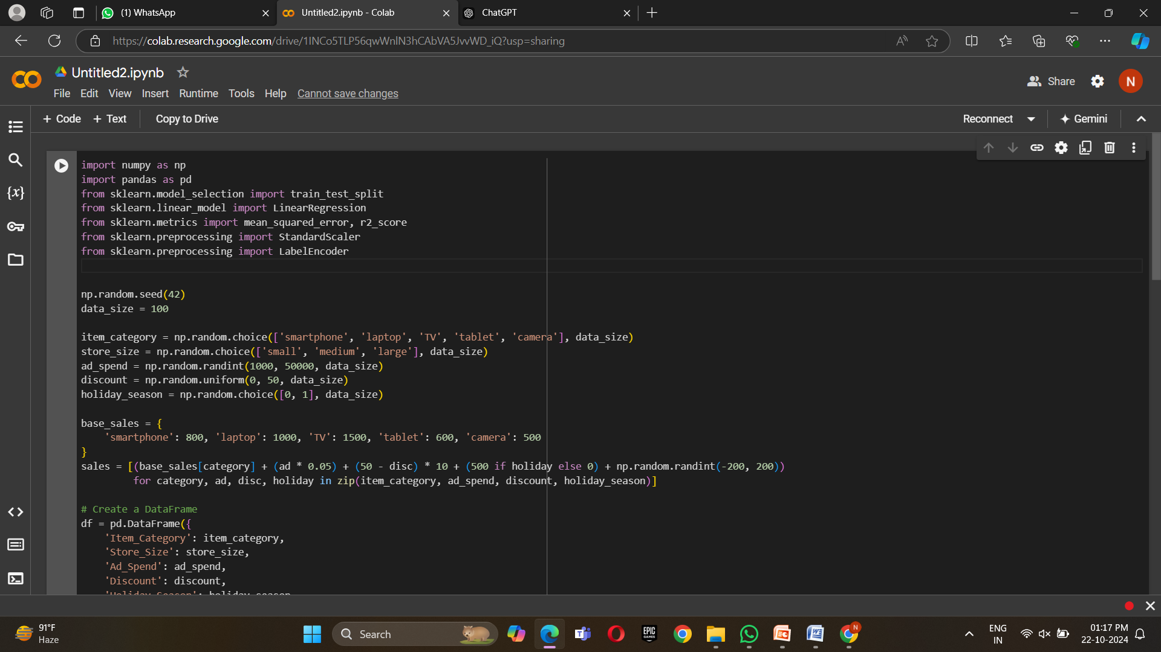

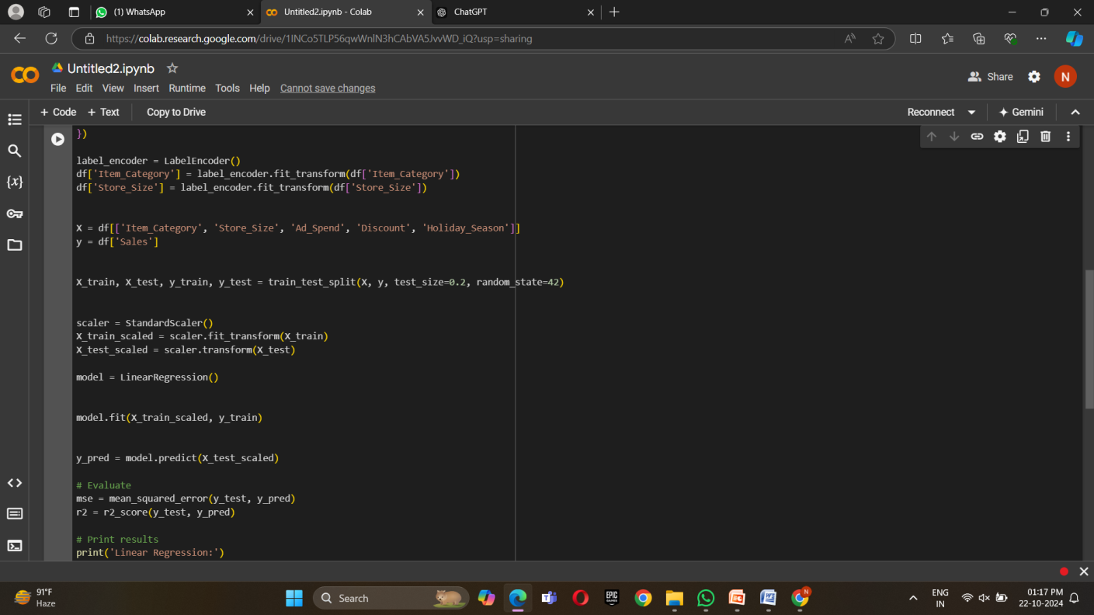

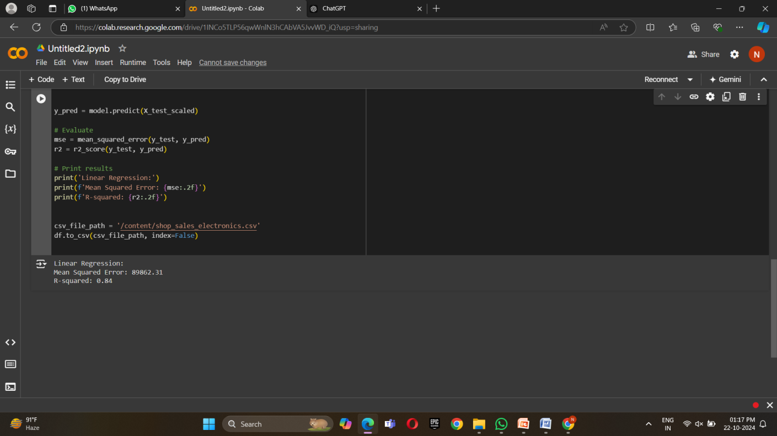

# Applications

### Inventory Management

* **Description:** Accurate sales predictions help businesses optimize inventory levels, ensuring that products are in stock when needed while minimizing excess inventory costs.

### 2. Demand Forecasting

* **Description:** Businesses can anticipate customer demand for products or services, allowing them to plan marketing campaigns, staffing, and production schedules accordingly.

### 3. Financial Planning

* **Description:** Sales predictions inform budgeting and financial forecasting, enabling companies to make strategic investments and allocate resources more effectively.

### 4. Marketing Strategy

* **Description:** Understanding future sales trends allows businesses to tailor their marketing efforts, target specific customer segments, and time promotions effectively.

### 5. Performance Analysis

* **Description:** Organizations can assess the effectiveness of sales strategies and marketing campaigns by comparing predicted sales with actual results, allowing for continuous improvement.

### 6. Pricing Strategy

* **Description:** Sales predictions can guide pricing decisions, helping businesses optimize prices based on anticipated demand and market conditions.

### 7. E-commerce Optimization

* **Description:** Online retailers can use sales predictions to enhance website performance, manage promotional efforts, and improve user experience based on expected traffic and demand.

.

# Future Work and Conclusion

As the field of sales prediction continues to evolve, several avenues for future work can enhance the model's effectiveness and applicability:

1. **Integration of Advanced Techniques:**
   * Explore the incorporation of advanced machine learning techniques, such as ensemble methods (e.g., XGBoost, LightGBM) or deep learning models (e.g., LSTM networks for time series data), to improve prediction accuracy.
2. **Incorporation of Real-Time Data:**
   * Implement real-time data integration from various sources, such as social media trends, economic indicators, and competitor activities, to refine predictions and adapt to market changes quickly.
3. **Customer Segmentation Analysis:**
   * Enhance the model by including customer segmentation, allowing for more tailored predictions based on different customer behaviors and preferences.

### Conclusion

In conclusion, this sales prediction project demonstrates the significant potential of machine learning techniques to provide accurate and actionable insights for businesses. By leveraging historical sales data and applying robust predictive models, organizations can optimize their operations, enhance inventory management, and make informed strategic decisions.

The project not only highlights the importance of data-driven approaches in today's competitive market but also sets the stage for future advancements in predictive analytics. As businesses continue to seek ways to improve their forecasting capabilities, ongoing research and development in this area will play a critical role in shaping effective sales strategies and enhancing overall performance. Through continuous improvement and integration of emerging technologies, the field of sales prediction can evolve to meet the dynamic needs of various industries, driving success and profitability in the long term.

# 

# References

### Online Resources

1. **Scikit-learn Documentation**. (n.d.). Retrieved from Scikit-learn
   * The official documentation for Scikit-learn, providing detailed descriptions of machine learning algorithms.
2. **Kaggle**. . Datasets. Retrieved from Kaggle Datasets